**DAY-5: (Functions- Anonymous & IIFE)**

1. Do the below programs in ANONYMOUS & IIFE function:

1. Print odd numbers in an array

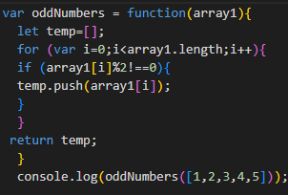

output:  **[1, 3, 5]**

2. Convert all the strings to title caps in a string array

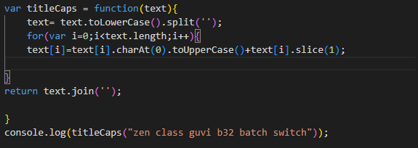

output: **ZEN CLASS GUVI B32 BATCH SWITCH**

3. Sum of all numbers in an array

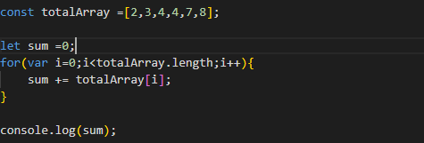

output: **28**

4. Return all the prime numbers in an array

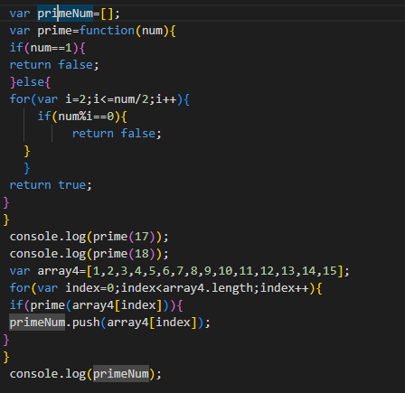

output:  **true,false,[2, 3, 5, 7, 11, 13]**

5. Return all the palindromes in an array

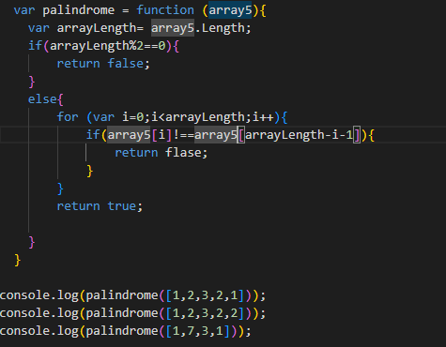

6. Return median of two sorted arrays of the same size

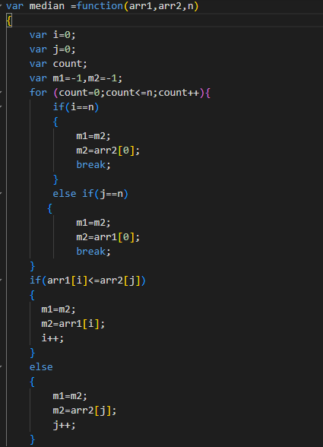

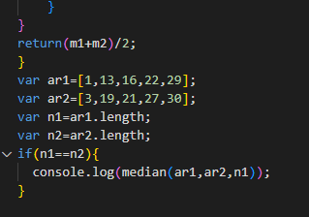

output:  **20**

7. Remove duplicates from an array

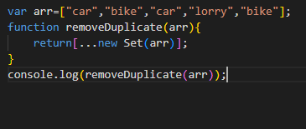

output:  **['car', 'bike', 'lorry']**

8. Rotate an array by k times

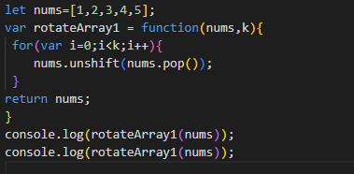

2. Do the below programs in arrow function:

1. Print odd numbers in an array

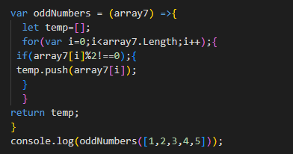

2. Convert all the strings to title caps in a string array

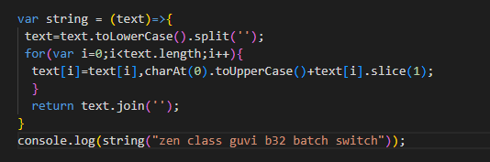

3. Sum of all numbers in an array

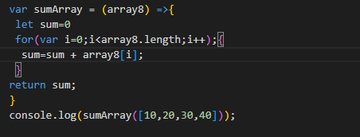

4. Return all the prime numbers in an array

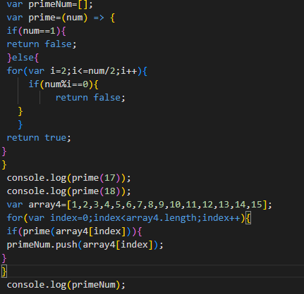

5. Return all the palindromes in an array

